Chapter 5
The Tools of the Trade

5.1–5.5: The action to be taken when two successive transaction records have the same key is shown in Figure 5.1.

In the flowchart of Figure 5.2 we assume that the last record in the old master file is a dummy record with key ZZZZZZ to ensure that the end of the old master file is never encountered before the end of the transaction file. In addition, we assume that the transaction file and the old master file are sorted as specified in Section 5.1.1 of the Sixth Edition of Object-Oriented and Classical Software Engineering.

Next transaction | Insert | Modify | Delete
Current transaction
Insert | Error condition | Insert, then modify | Do nothing
Modify | Impossible if input file is sorted | Perform second modification | Delete record
Delete | Impossible if input file is sorted | Impossible if input file is sorted | Error condition

Figure 5.1. Action to be taken when two successive transaction records have the same key.
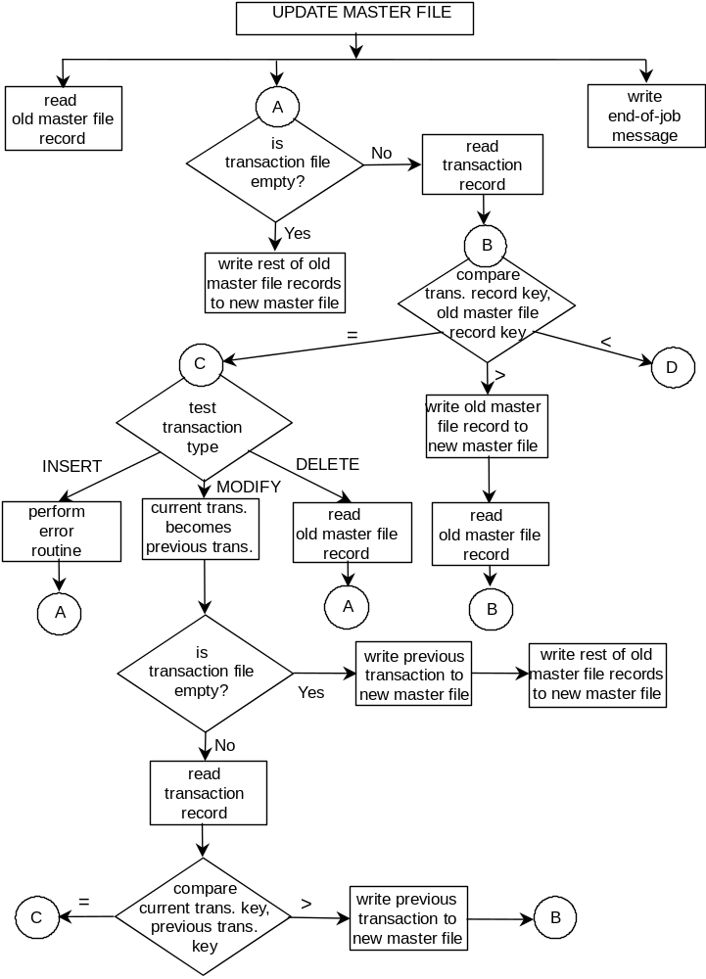
Figure 5.2. Flowchart for sequential file update using level-1 lookahead (Part 1 of 2).

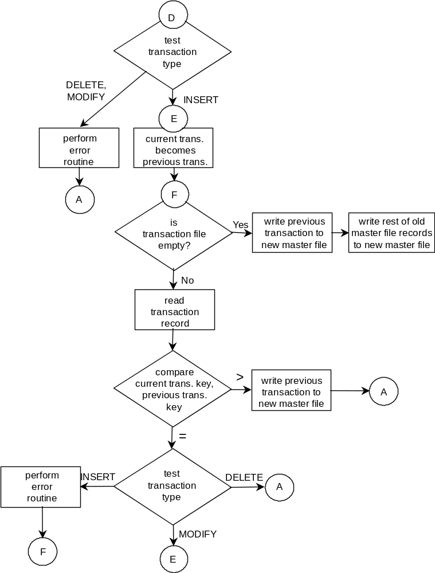
Figure 5.2. Flowchart for sequential file update using level-1 lookahead (Part 2 of 2).

The flowchart of Figure 5.2 solves all the difficulties in Problems 5.4 though 5.6.

5.6: There are six possible orderings:

1. INSERT, DELETE, MODIFY. This does not work when an INSERT is followed by a DELETE of the same record.
2. INSERT, MODIFY, DELETE. Ordering in the textbook.
3-6. The remaining four orderings (in which INSERT comes either second or third) also will not work because INSERT has to precede both DELETE and MODIFY.

5.7: Cost–benefit analysis will help the committee to decide whether it would be more advantageous for the Concordian government to do nothing, or take active steps to alleviate the problem.

Health care costs are of two types, preventative medicine (inoculating the populace, assuming that a vaccine exists) and treating the victims. The cost of preventative medicine can be estimated by multiplying the total number of Concordians by the cost of inoculation; the latter figure can be furnished by the Department of Health on the basis of previous inoculation campaigns. The cost of future treatment can be estimated using data regarding the cost of treating current victims of the disease; its future incidence can be estimated using epidemiological methods. The total treatment cost is then the cost per victim times the estimated future number of victims.

Loss of earnings and taxes for two weeks’ sickness can be estimated from tax records, assuming that the disease attacks members of every socioeconomic group equally.

Pain and discomfort can be estimated by examining the awards for damages in civil suits with a similar level of discomfit.

Gratitude towards the government could be estimated by multiplying the cost (in government spending) of buying a vote by the number of votes estimated to be lost to the opposition if the disease is not eradicated; the latter figure can be obtained by taking an opinion poll.

5.8 A version control tool is essential for all types of software development and maintenance; it may come as part of the operating system.
5.9 A configuration management tool is highly desirable because it is difficult for anyone to keep control over multiple modules, irrespective of the size of the development organization. If a configuration management tool costs too much for a small organization, just a version control tool will have to suffice.

5.10: Paul, Quentin, and Rachel make local copies of each of the four modules, and determine what changes each will make. Each in turn then freezes the current version of all four modules, makes changes, and has the changes tested by the SQA group. The changed version becomes the baseline version, local copies of which are then distributed to the remaining maintenance programmers. The baseline versions of the four modules must be under the personal control of the manager to ensure that this procedure is followed exactly in the absence of an automated tool.

